**Connections for sustainability in fashion and design through a material library**

***Conexões para sustentabilidade na moda e design por meio de uma biblioteca de materiais***

**Lauro Cohen, Msc., University of State of Pará**

laurocohenn@gmail.com

**Nubia Suely Silvia Santos, Dra., University of State of Pará**

nubiasantos@uepa.com.br

3E

**Abstract**

The relationships between fashion, design and materials promote important reflections on sustainable development, social, environmental and cultural responsibility. In this sense, biodiversity can be understood as a cultural heritage of intangible value, capable of being added to different productions and in the training of new professionals. Thus, this research presents connections on sustainability through the actions, over 13 years, of the Materioteca of the University of Pará, a collection of materials focused on Amazonian biodiversity. The research is classified as exploratory and the method employed is the case study. As results, analyses of the collection samples, curation process, Research & Development initiatives and organization of exhibitions are presented. In addition, the article presents associations of the actions with the Sustainable Development Goals (SDGs) of the 2030 Agenda. The main result identified is the contribution of the space to educational initiatives, with participatory approaches, and the synergy with SDG 4 – Quality Education and SDG 12 – Responsible Consumption and Production.

**Keywords:** Education; Raw Material; Material Collection; Material Selection; Biodiversity.

***Resumo***

*As relações entre moda, design e materiais promove reflexões importantes sobre desenvolvimento sustentável, responsabilidade social, ambiental e cultural. Nesse sentido, a biodiversidade pode ser compreendida como um patrimônio cultural de valor intangível, capaz de ser agregado em diferentes produções e na formação de novos profissionais. Desta forma, a presente pesquisa apresenta conexões sobre sustentabilidade através das atuações, ao longo de 13 anos, da Materioteca da Universidade do Pará, um acervo de materiais com foco na biodiversidade amazônica. A pesquisa é classificada como exploratória e o método empregado é o estudo de caso. Como resultados, são apresentadas análises sobre as amostras do acervo, processo de curadoria, iniciativas em Pesquisa & Desenvolvimento e organização de exposições. Além disso, o artigo apresenta associações das ações com os Objetivos do Desenvolvimento Sustentáveis (ODS) da Agenda 2030. Identifica-se como principal resultado a contribuição do espaço para iniciativas educativas, com abordagens participativas, e a sinergia com o ODS 4 – Educação de Qualidade e ODS 12 – Consumo e Produção Responsáveis.*

***Palavras-chaves:*** *Educação; Matéria-prima; Coleção de Materiais; Seleção de Materiais; Biodiversidade*

1. **Introduction**

The fashion industry, historically known for its negative impacts, is challenged to adopt sustainable practices and less polluting processes. Designers must be increasingly more efficient in their choices, with the aim of reducing waste and promoting a fairer society. This issue generates ongoing developments that lead designers and consumers to rethink their daily attitudes, through a reorganization of each citizen's worldview (BERLIN, 2016).

Thus, it is understood that responsible production and consumption is a global challenge in different Fashion and Design projects. This commitment is also present in the United Nations (UN) 2030 Agenda, through the Sustainable Development Goals (SDGs).

Amazonian biodiversity and its inputs have been used in the food and cosmetics sectors as a source of raw materials, in addition to being the subject of intense discussions, workshops, fairs and other events that are taking place and will take place in Belém (Pará - Brazil) on the eve of COP 30 - United Nations Conference on Climate Change. One of the first steps to make this happen is to encourage engagement in recognizing the importance of this biodiversity and its sustainable use for local communities and the world.

Biodiversity as a regional/local cultural heritage becomes an intangible value that can be added to products through Fashion or Design. In this way, seeds, fibers or wood, once an integral part of a product, carry within them the value of the forest, the value of the riverside dweller, extractivist or indigenous person who collected the seeds, the fruits, who extracted and processed the fibers. Intangible aspects that become tangible, in the form of value for the region.

The use of materials is rooted in human culture, much more than one might imagine. Historically, the development and advancement of society were directly linked to the skills of producing and manipulating materials for human needs. In some cases, it is common to associate certain civilizations with their relationship with materials, such as the Stone Age, Bronze Age or Iron Age (CALLISTER; RETHWISCH, 2018).

Since materials are the basis for Design and Fashion projects, capable of determining the limits and opportunities for a product, as well as being responsible for its materialization, the selection of materials is of utmost importance in product development. Due to the diversity of existing materials and their characteristics, it is important for designers, engineers, architects or planners to study and analyze materials in terms of their characteristics and production processes, and possible impacts on the environment.

The objective of creating a Materials Library is to compile materials so that professionals (such as designers, architects or engineers) and students can access the variety of samples and encourage the use of different existing materials. The UEPA Materials Library is a project that is a space open to the public and at the service of knowledge about Amazonian materials and their production processes. Linked to the Bachelor's Degree in Design, the space offers a collection of samples divided into six classes of materials.

In view of the topics presented, this paper presents connections between sustainability and biodiversity, through the actions of the UEPA Material Library over 13 years. The research is classified as exploratory and the method used is the case study. It is expected that the article can contribute to the literature dedicated to the actions and experiences of Material Libraries, in addition to investigations related to the topics discussed.

1. **Perspectives on sustainability in fashion, design and materials**

Sustainability is the subject of different dialogues between consumers, researchers and designers, with in-depth engagement amid the crisis and the impacts of climate change. To meet current demands, in 2015, a General Assembly convened by the UN resulted in the document entitled “Transforming Our World: the 2030 Agenda for Sustainable Development”. This document was prepared following a structure with 17 objectives, as shown in Figure 01.

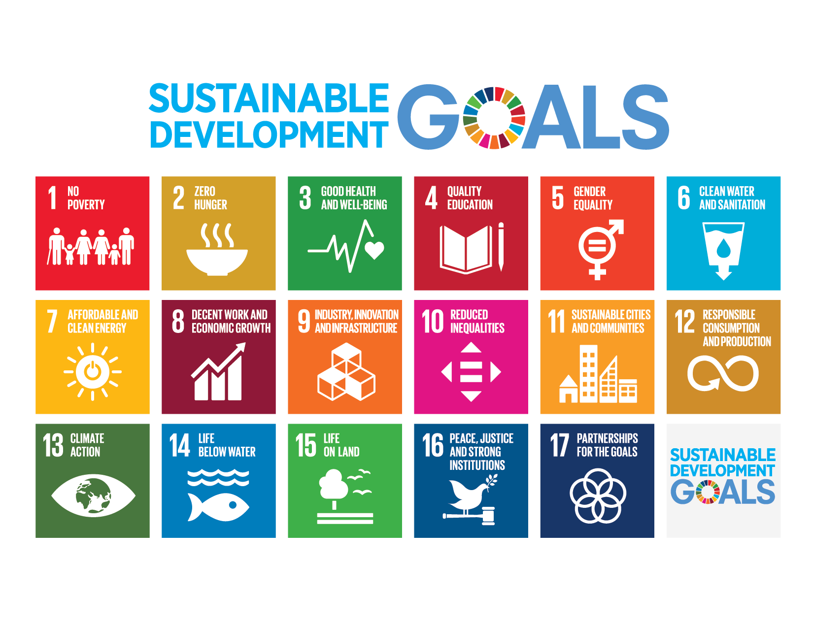

**Figure 1: Sustainable Development Goals. Source: UN, 2015**

According to the World Design Organization, the design process in fashion or design, linked to sustainability, can provide an innovative perspective on the challenges of the 2030 Agenda. The organization identifies the role of designers as relevant in SDG 3 - Good health and well-being; SDG 6 - Clean water and sanitation; SDG 7 - Affordable and clean energy; SDG 9 - Industry, innovation and infrastructure; SDG 11 - Sustainable cities and communities; SDG 12 - Responsible consumption and production; SDG 17 - Partnerships for the goals (WDO, 2020).

A relevant aspect in sustainability-oriented agendas is the strong impact that the fashion and design industries have on biodiversity. Clothing supply chains, for example, are directly linked to soil degradation, conversion of natural ecosystems and water pollution. Most of the negative impact comes from three stages in the value chain: raw material production, material preparation and processing, and end-of-life (GRANSKOG et al., 2020).

The current scenario highlights the need for collaborative efforts, which can be driven or based on the 2030 Agenda. Thus, it becomes relevant to categorize and indicate connections so that its guidelines can be used to disseminate sustainable alternatives, whether through communication, education, clean production processes, or alternative materials (THAKKER; SUN, 2023).

In the Amazon context, the vast biodiversity and natural wealth offer enormous potential for the development of sustainable practices in fashion and design. The conscious exploration of resources such as natural and organic fibers and plant materials can promote ecological and innovative alternatives, reducing the environmental, social, and economic impact of industries. By incorporating practices that respect ecosystems, designers and designers can create products that combine functionality and respect for the environment, in a responsible and inclusive consumption cycle.

1. **Material Library UEPA**

Material libraries are spaces for research and documentation, through a physical and/or digital database, organized as instruments for knowledge, access to data and dissemination of information (DEL CURTO; BERTOLDI, 2018). The Material Library UEPA is located in the Center for Natural Sciences and Technologies, on Campus V of the State University of Pará (UEPA).

The initiative, as shown in Figure 3, was implemented with the objective of offering academics on the campus, and the general community, technical information on materials and production processes, through tactile and visual interaction with samples present in the consumer goods industries. The organization of the space is conducive to creativity and innovation, the arrangement of the information seeks to offer visitors the ability to relate materials and processes with the production chains existing in the North region.

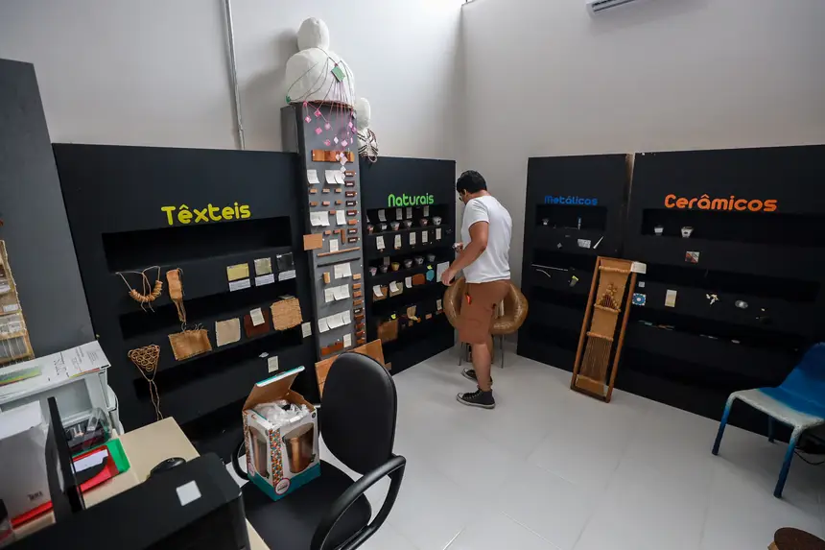 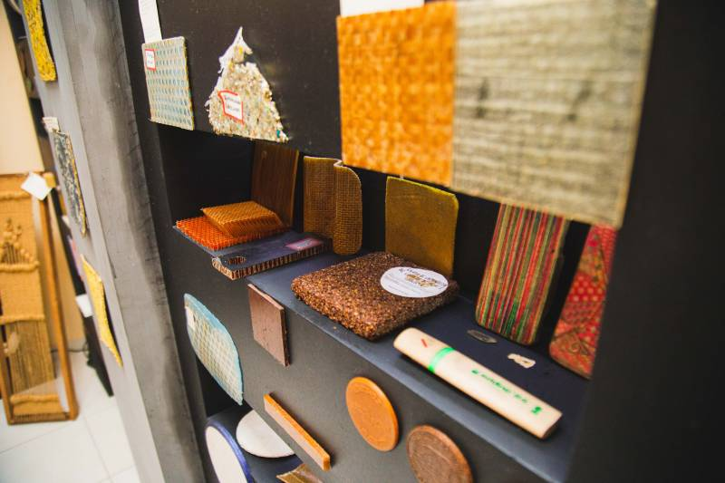 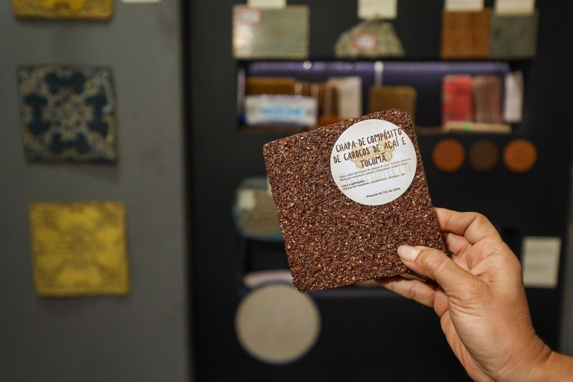

**Figure 3: UEPA Material Library Space. Source: ASCOM UEPA – adapted by the authors.**

One of the activities for teaching is supporting subjects in the Bachelor's Degree in Design, which involve fashion education and product development, such as: Materials and Processes, Modeling, Project and Sustainable Design. In addition to the physical space, the initiative also has activities in the digital environment. Dedicated to the academic public and people interested in design, materials and sustainability, the account @materiotecauepa (Instagram) uses different resources to share part of the collection and communicate the project's activities (COHEN; SANTOS, 2022).

Traditionally, materials are classified as metallic, polymeric, ceramic and composite. With the need to know the materials that the forest has long offered us, and to recognize their importance in the development of the local economy, the class of natural materials was created, which, for the purposes of this project, are defined as natural materials of plant origin, where we find various fibers, alternative woods, seeds, among many others. The “textiles” class found relevance in this project, since it is an important area for Fashion and Design, in addition to the existence of a textile industry in the state of Pará.

Since the beginning of the project, in 2012, the implementation of the UEPA Material Library required studies on different fields of knowledge, on the categorization of materials, organization and curation of exhibitions, organization of scenographic spaces, educational processes and the dynamics in museum spaces. The studies were important for the foundation of the project's work and initiatives over the years (COHEN; SANTOS, 2024). Currently, research and activities with participatory approaches are being carried out, aimed at sustainable development, the formation of critical thinking and the use of space for teaching/learning.

1. **Methodological Procedures**

Regarding the methodological procedures, the data and information were collected through exploratory research. According to Gil (2026), exploratory investigations seek to provide an overview of a given fact, in addition to contributing to the explanation of certain phenomena and/or causes. The method applied was the case study, which consists of researching one or more cases, in a way that allows for broad and detailed knowledge. The investigation aims to analyze and record facts in order to later interpret them in a narrative way (SILVA-NETO; LEITE, 2023).

Thus, during the first stage of the research, the analysis of the activities related to the Materioteca's operations over 12 years was carried out. The survey of actions related to obtaining samples from the collection, the curation process, Research & Development initiatives and the organization of exhibitions was delimited. The objects of study were obtained through visits to the space, searches in the space's archives and web materials available on institutional pages.

To associate the actions with the Sustainable Development Goals, during the second stage of the investigation, a framework was created to relate the actions described in the text with the targets set out in SDG 4 – Quality Education and SDG 12 – Quality Production and Consumption. The information on each target was transcribed from the technical material of the 2030 Agenda (UN, 2015).

1. **Results e Discussion**

In order to organize the collection samples in a didactic manner, we first sought to understand the classification found in the classical literature on the subject. Thus, the classification described in the book “Materials Science and Engineering - An Introduction” (CALLISTER; RETHWISCH, 2018) was adopted. Traditionally, materials are classified as Metallic, Polymeric, Ceramic and Composite. As an innovation, two classes were added to the collection's exhibition design: textile and natural materials.

In total, the space has a collection of more than 600 samples. In the metallic materials class, there are samples of ferrous and non-ferrous metallic materials (aluminum, copper, tin, magnesium, recycled aluminum, bronze alloys, etc.). In the ceramics class, there are samples of mineral materials (inputs) that are part of the ceramic industry chain, ceramic, cementitious, lithic products and small red ceramic artifacts. In the polymers class, there are samples of vinyl coatings, recycled polymer tablets and small 3D printed artifacts. In the composites class, there are samples of polymeric composites, cementitious, biocomposites and products with composite materials.

In addition to the class of natural materials, which includes raw materials representing the Amazonian plant biodiversity, the class of textile materials was also added to the project, since it is an important area for Fashion and Design, remembering that many plant fibers already classified as natural materials of plant biodiversity, such as Miriti, Curauá, and Tururi, can be transformed into textile artifacts.

Another important factor in the creation of this class in the project was the existence in the region, state, of a textile hub based on the cultivation of jute fiber. Bringing this discussion to the Amazonian context is relevant since the classification of textiles is widely found and categorized in the area of ​​textile engineering and technology, the acquisition of textile materials and processes, and the classification of fibers.

In the textile materials class, the space has 70 samples of textile fibers, synthetic and/or natural fabrics, organized in reels, woven fabrics, knitted fabrics or processed artifacts. As for natural materials, the space categorized 80 samples of plant origin, including: fibers, seeds, recycled paper, petioles, wood and products of cellulose origin, organized in blocks, screens, sheets, granules and processed products - organized in Board 1.

Board 1: Classification of the collection directed to the Textile and Natural class

|  |  |  |  |  |
| --- | --- | --- | --- | --- |
| **Material Library UEPA Collection** | | | | |
| **Class** | **Samples Types** | **Samples Geometry** | **Main materials** | **Applications in Fashion and Design projects** |
| Naturals | Samples of plant origin (plant fibers, seeds, recycled paper, petioles, alternative woods) and products of cellulosic origin (crafts or consumer goods industry) | Blocks, sheets, screens, products, granules | Seeds (Acai, Jupati, Buriti, Paxiuba and Tucumã), Fibers (Acai, Coconut, Jupati, Miriti and Banana), Woods (Jatobá, Angelin, Yellow Ipê, Cumaru, Masssaramduba, Timborana and Muiracatiara) | Biojewelry, Furniture, Clothing, Reinforcement for composite materials (new materials), Adornments, and Packaging |
| Textiles | Samples of natural textile fibers and synthetic fabrics | Fabrics, reels and textile artifacts | Jute Fabric, Tururi, Jute/Cotton (Hybrid), Raw Cotton, Calico, Felt(s), TNT(s), Cotton Viscose, Jute Yarn, Jute Fiber, Carded Jute and Cotton Yarn | Clothing, Accessories, Bags, Shoes, Ornaments, Wallets, Belts and Packaging |

Source: Authors. 2025

Access to the space is via guided tours, conducted individually or in groups. This is the moment when visitors are encouraged to have sensory experiences with some sample from the collection, with the free handling of the material. Through a technical sheet placed next to each sample, it is possible to have access to information about the selected sample, such as production processes, environmental, cultural and technical aspects.

By integrating traditional and scientific knowledge, the technical data sheets in the material library can become powerful tools of inspiration for design and fashion designers. In the field of traditional knowledge, the data sheets can detail the cultural origin of the material, the ancestral production and processing techniques, the associated symbolic meanings, the historical applications and the communities that hold this knowledge. Including narratives that contextualize the use of the material within the local culture, its intrinsic properties empirically observed over generations and the sustainable practices of natural resource management can awaken designers' sensitivity to the cultural richness and ancestral connection with the raw material.

In addition, the incorporation of scientific knowledge complements traditional understanding with objective and measurable data. Information such as chemical composition, physical properties (resistance, durability, flexibility), as well as studies that validate or deepen traditional knowledge, provide a solid basis for innovation. This fusion of perspectives allows Amazon designers to explore the potential of materials more consciously, combining aesthetics and cultural meaning with technical performance and sustainability, resulting in creations that transcend functionality and carry a rich and relevant history.

The methodology for approaching the content of the Material Library follows the method outlined by Manzini and Vezoli (2016), based on the life cycle of a product, comprising all its stages and processes, from birth to death, in relation to the environment and the actors in the production chain. It is understood that during all phases of this cycle, the product undergoes transformations and affects the environment, requiring material, energy and releasing its emissions throughout the process. The approach chosen to present the information voluntarily initiates awareness aimed at responsible production and consumption, since information about the processes and materials is made available and evaluated.

In the Material Selection process for Fashion and Design projects, the role of the UEPA Material Library is linked to supporting decision-making, so that the professional can assess the possible impacts and consequences of a product, as well as choose the message that the project aims to convey. As a way of exposing sustainability issues, information linked to traditional Amazonian knowledge was also attributed, through a confluence of indigenous, quilombola, riverside and technical-scientific knowledge. Figure 4 illustrates how the samples and technical data sheets of the materials are presented.

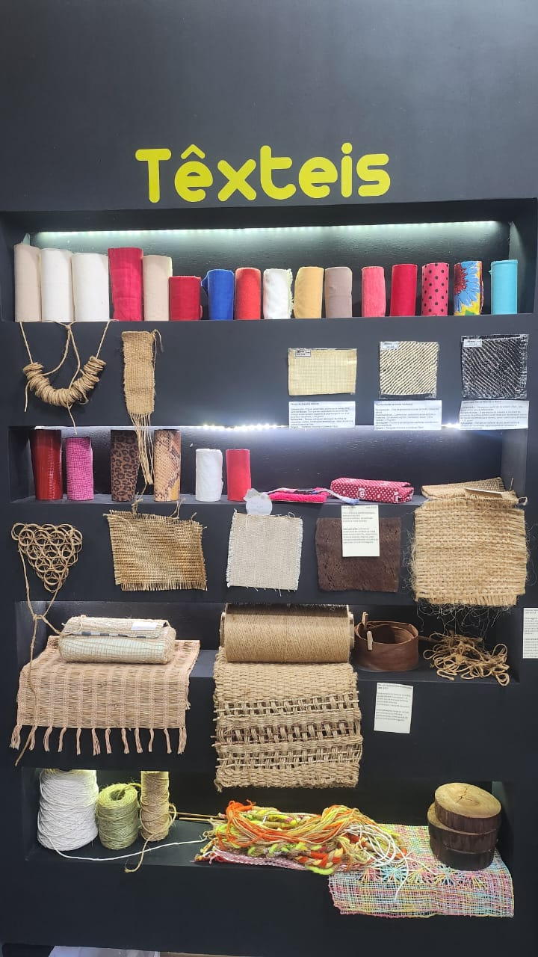 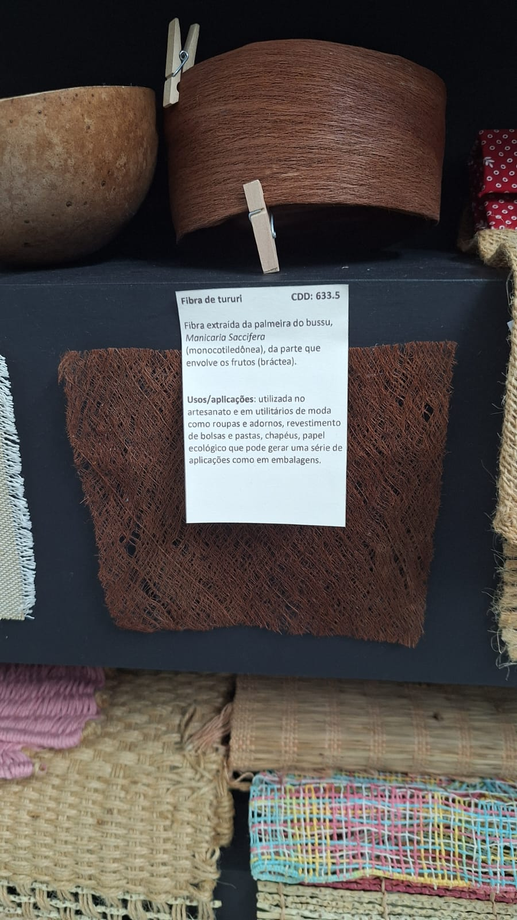 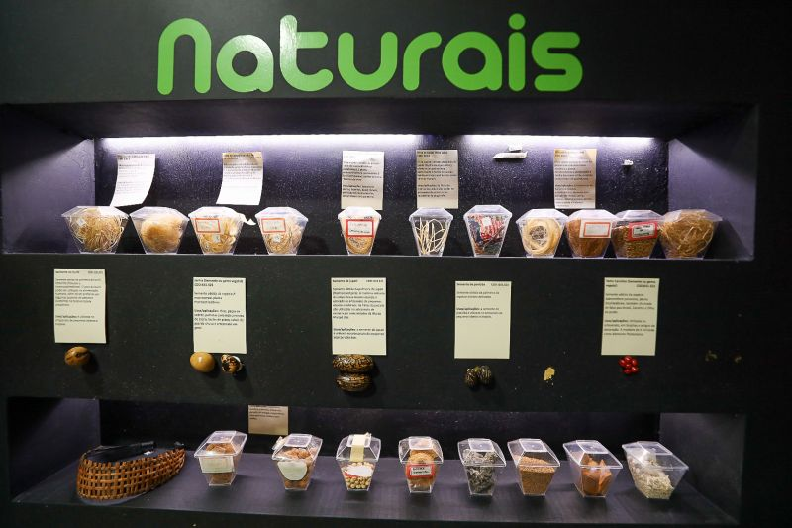

**Figure 4: Presentation of samples and sheets with specific information. Source: Authors.**

The acquisition and obtaining of the samples that make up the collection are done in different ways, whether by purchasing at craft fairs, contacting manufacturers to request them, or voluntary donations through scientific expeditions and technical visits to traditional communities located in the state of Pará (Brazil). In addition, samples developed in scientific initiation research, or that are the result of research in the area of ​​materials and processes, also go through a curation process and can be part of the collection/exhibition.

The organization that prioritizes the appreciation of raw materials, such as the display of samples in their raw form or at different stages of processing, allows visitors to have a deep visual and sensory connection with the origin and essence of natural materials and textiles. The playful and summarized presentation of technical sheets, using visual resources, infographics and even interactive installations, facilitates the understanding of the properties, applications and stories behind each material, making learning intuitive and memorable.

In addition, providing tactile contact with raw materials is a crucial element in awakening creativity. The sensory experience of touching different textures, feeling the weight, malleability and shape of materials stimulates the imagination and evokes new possibilities of application and combination. This direct physical interaction, combined with accessible and visually appealing information, nurtures curiosity and encourages mental experimentation, paving the way for the generation of innovative ideas in design and fashion, where materiality is a central element of creative expression.

In a context of Research & Development, there are local alternatives for the use of fibers from residues from consolidated production chains in the region, as shown in Figure 5. For example, the use of Açaí fibers to produce a non-woven textile and the development of a material similar to leather, with fibers from the crown of the pineapple, for making cases, wallets and accessories.

**a) 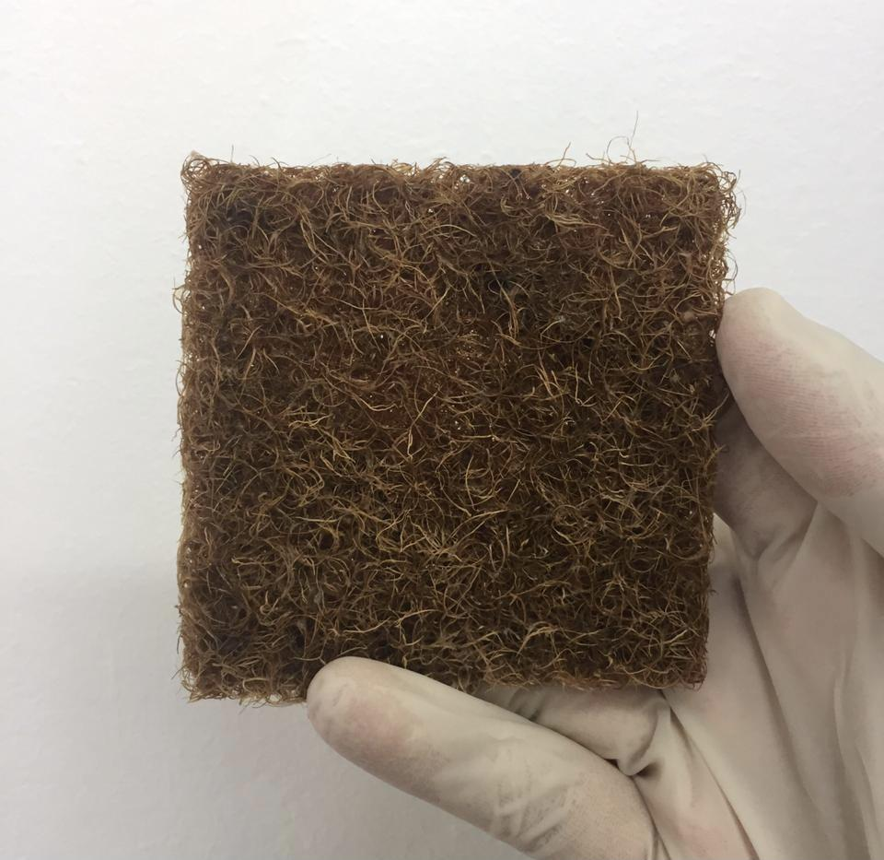 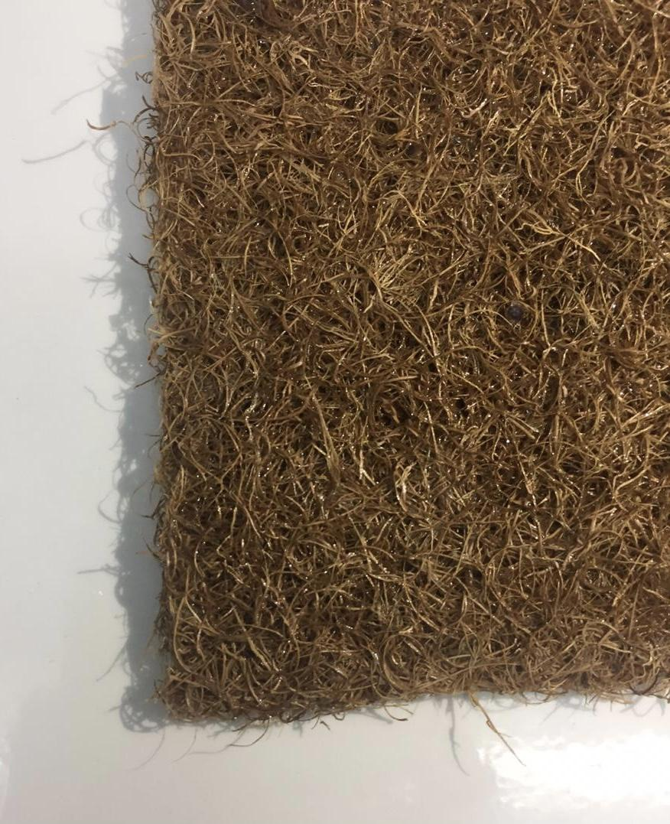 b)**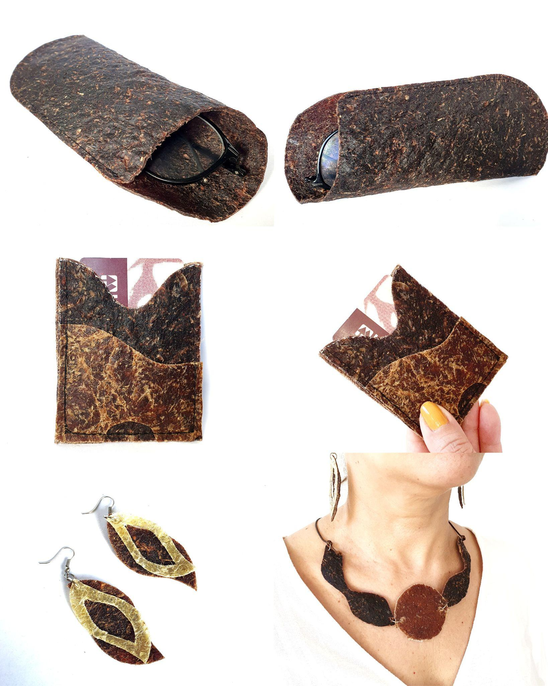

**Figure 5: Material samples a) Non-woven with Açaí Fiber; b) Biomaterial with Pineapple Crown Fiber. Source: a) Cohen; Santos, 2022 b) Cotta, 2022**

As a cultural facility linked to artistic production and teaching, the UEPA Materials Library offers a space for exhibitions of Final Course Works (TCC) or prototypes from the Materials and Production Processes disciplines of the Design course. In October 2015, the exhibition Tramas em Prece (Figure 6) had as its theme the Círio de Nossa Senhora de Nazaré. The procession and the promises of the faithful were interpreted in pieces produced by hand, using jute threads, calico fabric, açaí seeds and miriti splints. As an attraction, visitors were invited to feel and touch the texture of the materials/art installation.

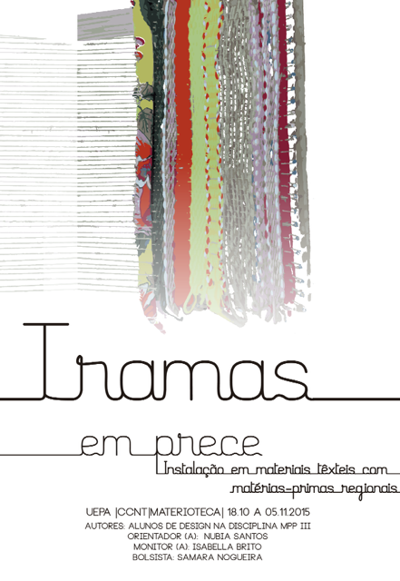 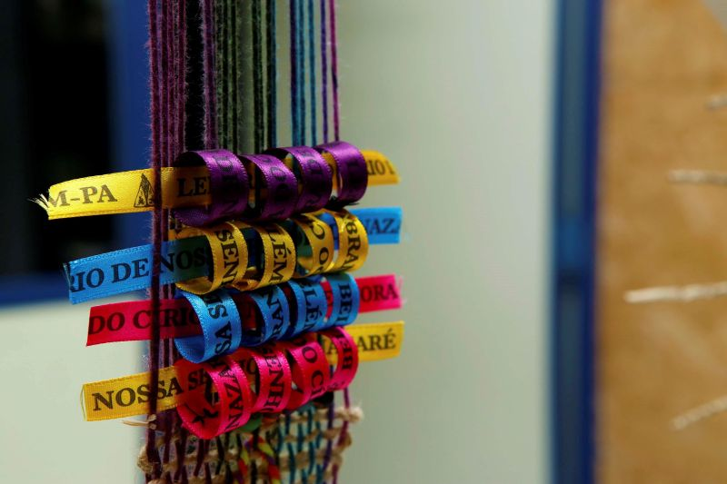 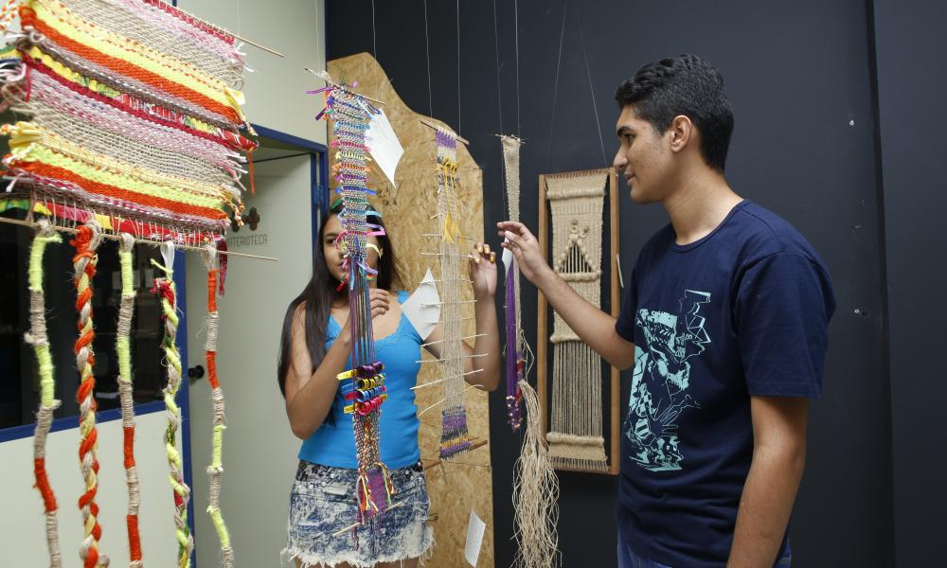

**Figure 6: Records of the Exhibition “Plots in Prayer”. Source: Authors.**

In 2018, the exhibition The Diversity of Life in Adornments (Figure 7) presented two TCC results with similar themes, as shown in Figure 7. The first brought together body ornaments (developed with recycled polymers) inspired by Pajubá - a dialect used by the LGBTQIAPN+ community.

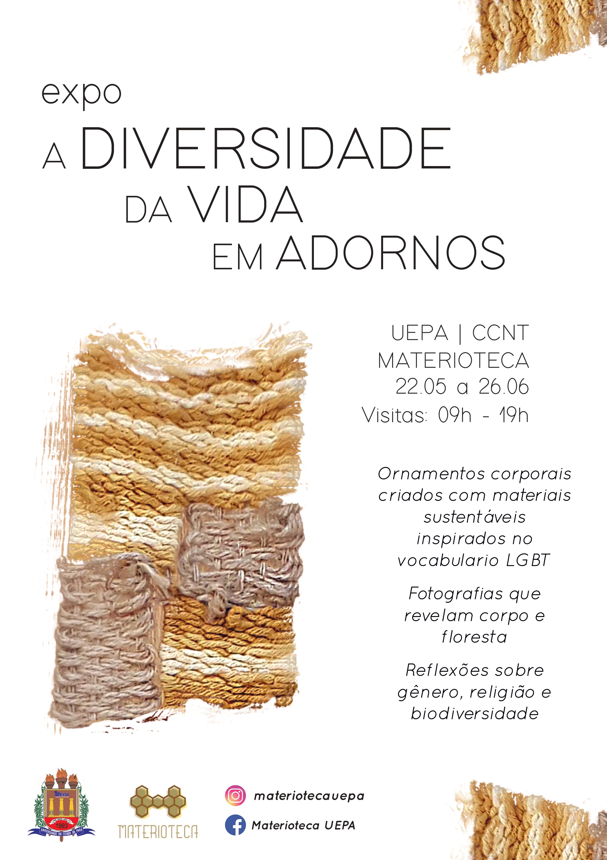 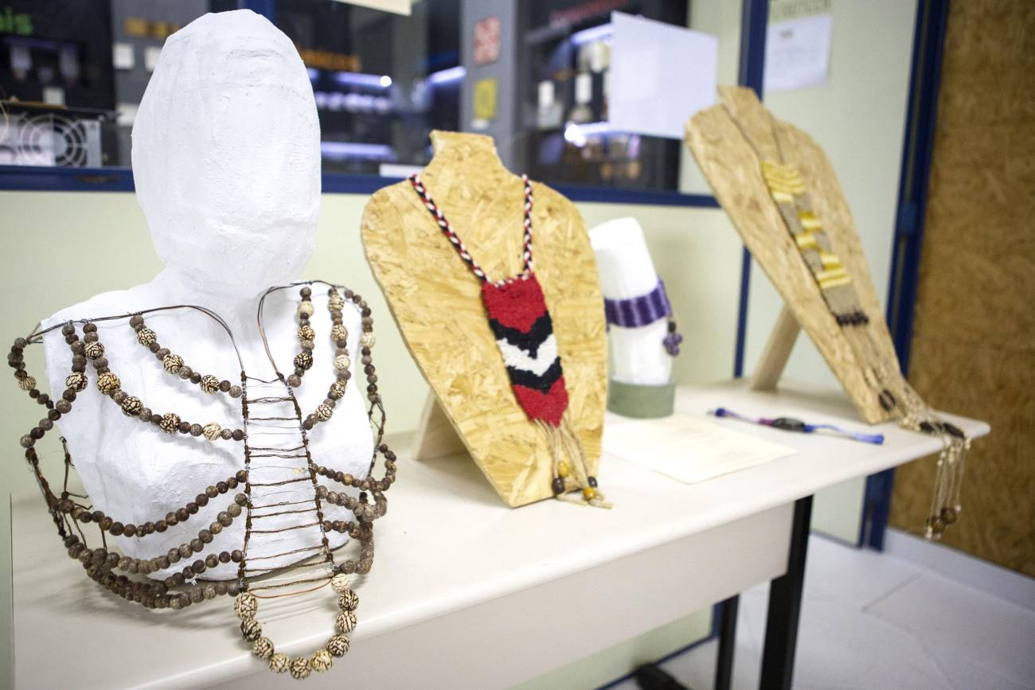 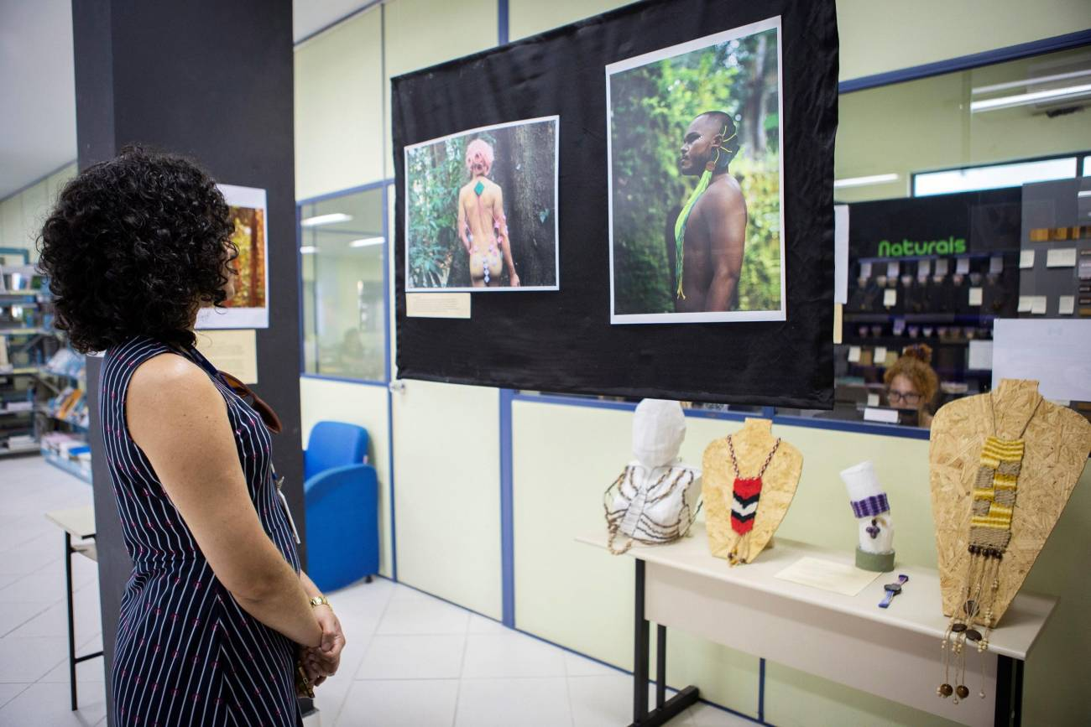

**Figure 7: Records of the Exhibition “The diversity of life in adornments”. Source: Authors.**

The second theme presented photographs that provoked reflections on the body and the forest, through African-based religiosity. Therefore, ornaments produced using hand-woven techniques, Tururi fiber, wool and natural seeds were developed and exhibited. Using alternative materials, the productions had in common the goal of providing visitors with reflections on fashion from the perspective of gender, religion and biodiversity.

Since the space was established, the educational and recreational potential of the project and the collection has been observed among elementary school students. As a result of this experience, in 2015, the opportunity arose for a systematic itinerary, seeking to reach students from the public elementary school system (Figure 8). Environmental education is like a process that provides people with a global understanding of the environment, which seeks to build values ​​and develop attitudes that make them take a conscious position in relation to environmental issues.

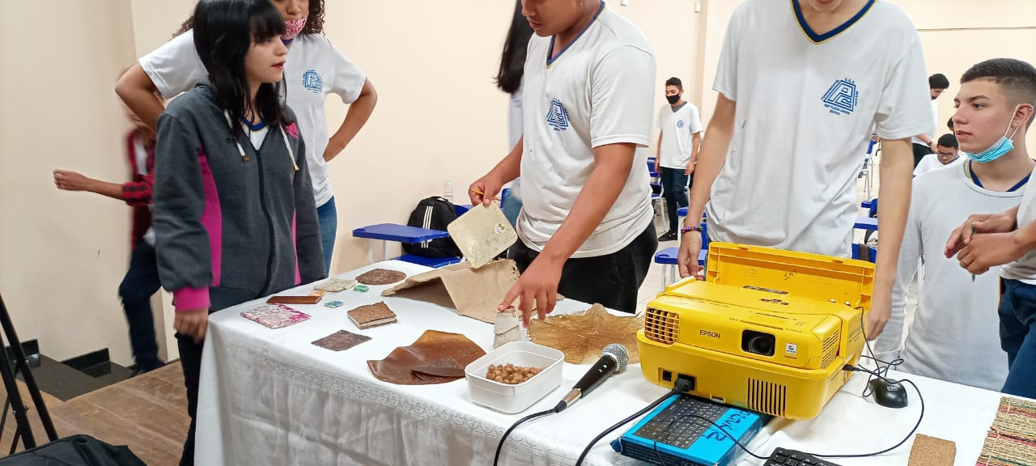 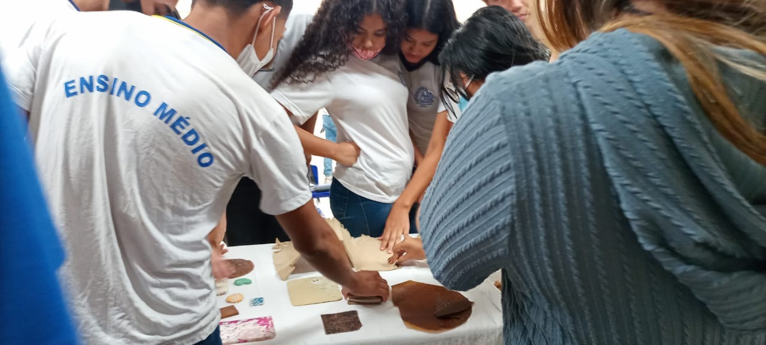 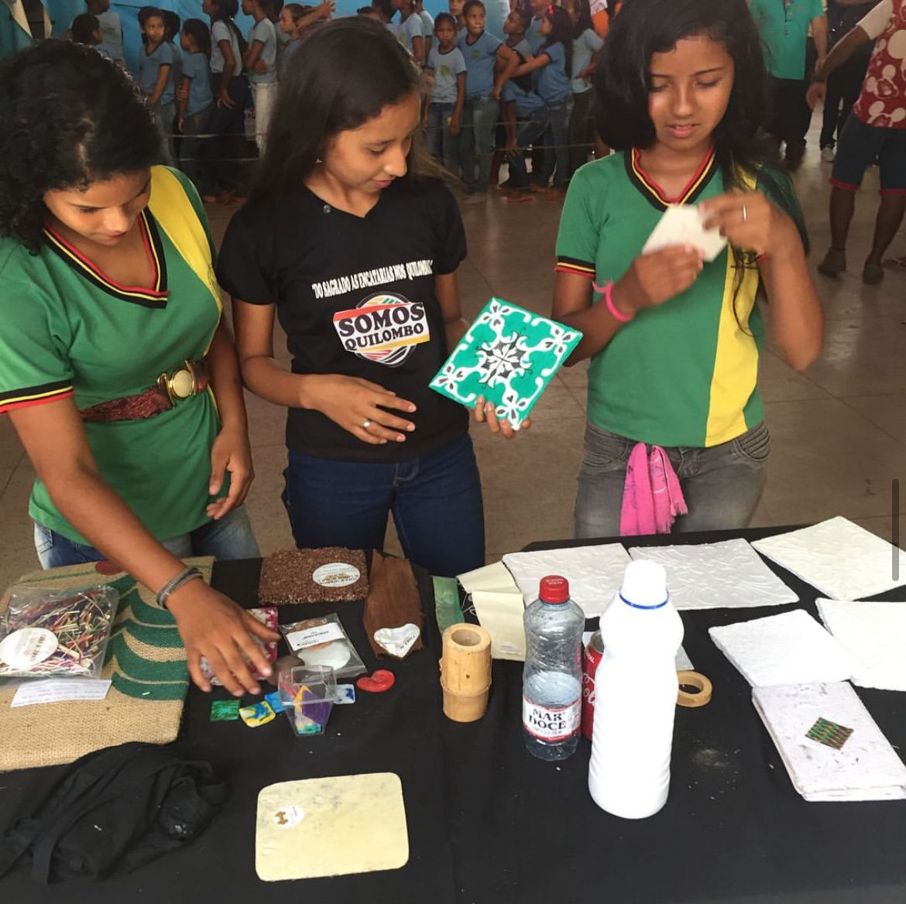 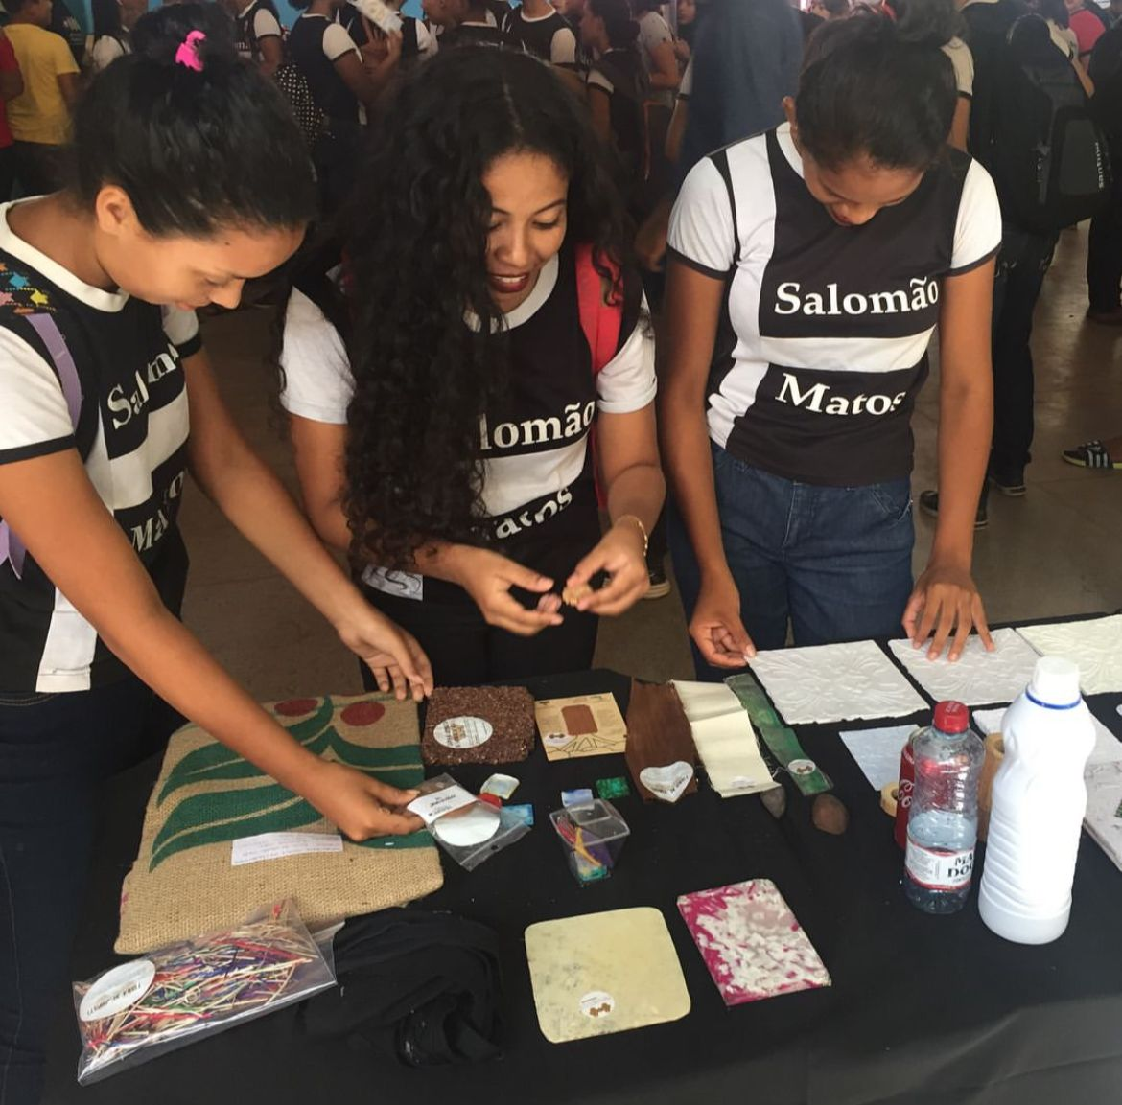

**Figure 8: Images of the Itinerant Material Library action. Source: Authors.**

The activities of the Itinerant Material Library project allow knowledge developed in an academic environment to go beyond the university barriers, while also being a way of giving back to the community and spreading the Amazonian sense of belonging. For high school and elementary school students, contact with samples and design/fashion products made from biodiversity materializes relationships that are often not perceived in everyday life.

In an educational way and through tactile contact, it allows them to understand that, in addition to synthetic and industrialized materials, there is value in natural/forest resources. Over the years, itinerant actions have taken place in more than seven public schools and four educational events in the state of Pará (Brazil), in the cities of Belém, Castanhal, Ananindeua, Paragominas and on Marajó Island.

Adherence to the Sustainable Development Goals and the commitments established in the 2030 Agenda are not completely binding on the actions of a material collection. However, it is essential that this relationship be internalized, since it is in the local context that policies and actions aimed at sustainable development are implemented. Thus, based on the initiatives indicated throughout the text, a parallel was drawn between the work of the Materioteca and the SDG agendas (Board 2).

Board 2: Relationships between the SDGs and the actions of the Material Library UEPA

|  |  |  |
| --- | --- | --- |
| **SDGs** | **Goals set by the 2030 Agenda, related to Fashion and Design (UN, 2015)** | **Material Library's activities based on the SDGs/planned goals** |
| Goal 4 .:. Sustainable Development Knowledge Platform  **SDG 4** *(Quality Education)* | 4.1 - Ensure that all girls and boys complete free, equitable and quality primary and secondary education that leads to relevant and effective learning outcomes;  4.2 - Ensure that all learners acquire the knowledge and skills needed to promote sustainable development, including, among others, through education for sustainable development and sustainable lifestyles, human rights, gender equality, the promotion of a culture of peace and non-violence, global citizenship and the appreciation of cultural diversity and the contribution of culture to sustainable development;  4.3 - Substantially increase the number of youth and adults who have relevant skills, including technical and vocational skills, for employment, decent work and entrepreneurship. | - Communication of technical knowledge to a general and/or academic audience;  - Support in the organization of cultural events (exhibitions and lectures);  - Participation in technical and scientific events on education;  - Support the formation of critical thinking among residents of the Pará Amazon. |
| **SDG 12** *(Sustainable Consumption and Production)* | 12.1 - Promote sustainable management and efficient use of natural resources;  12.2 – Substantially reduce waste generation through prevention, reduction, recycling and reuse;  12.3 - Ensure that people everywhere have relevant information and awareness for sustainable development and lifestyles in harmony with nature;  12.4 - Support and strengthen scientific and technological capabilities to encourage more sustainable patterns of production and consumption. | - Curation of sustainable materials and products;  - Support for research projects using agro-industrial waste from the Amazon;  - Support for the use of renewable resources and/or clean processes in the development of academic projects and products. |
| Goal 15 | Department of Economic and Social Affairs  **SDG 15** *(Life on Land)* | 15.1 - Ensure the conservation, restoration and sustainable use of terrestrial and inland freshwater ecosystems and their services, in particular forests;  15.2 – Provide ways to conserve ecosystems, including their biodiversity, to enhance their capacity to provide benefits that are essential for sustainable development;  15.3 – Integrate ecosystem and biodiversity values ​​into national and local planning and development processes. | - Guidance for the use of materials with low impact on terrestrial life;  - Inclusion of local stakeholders in the feasibility of sustainable production processes in product and projects;  - Integration of traditional knowledge with scientific research in research centers and universities |

Source: Authors. 2025

By showcasing samples of natural materials from the Amazon and sustainably produced textiles, the initiative directs designers on environmentally friendly alternatives that are directly related to SDG 15. By highlighting materials from responsible forest management and recycling, the material library demonstrates the viability of using land resources in a way that protects ecosystems and prevents degradation.

The appreciation of alternative processes reinforces the importance of responsible forest management and combating deforestation, which are key elements for protecting and restoring Amazon forests and maintaining biodiversity. This perspective, which places the sustainable aspects of life on earth at the center of the possibilities for design and fashion projects, transforms the classic perspective in which economic benefits and consumer trends are initial design premises, predominantly related to SDS 12.

As shown in the table, 1 the representation of the SDGs helps to understand the commitment to placing climate change and the fight against inequalities at the center of economic policies, with the biosphere being the main focus of the discussion, without which nothing else exists, and which is the basis for sustaining social and economic life. Subsequently, society is understood - which in addition to basic premises of human dignity also encompasses political, cultural and institutional objectives - and the economy as an integral part of the other areas (ABRAMOVAY, 2019).

Although SDG 4 does not directly address possible contributions by designers to Agenda 2023, Materioteca's work has a strong contribution to the Goal, by promoting educational initiatives for designers and non-designers, with its itinerant work being a specific example of this contribution. The articulation between the actions and the SDG guidelines allows the project to act as an academic instrument for people to think about sustainability, from the connection and preservation of life on earth to more educational issues. Through the panorama presented in this article, it is indicated that the project has interrelations with other SDGs, such as 9, 11 e 17.

This issue reinforces a thought found in the literature, in which to achieve sustainability parameters in Fashion and Design, it is necessary for solutions to present alternatives based on broad and systemic issues in the production chain (THAKKER; SUN, 2023). Making Fashion and Design in the Amazon is much more than dressing, footwear or adorning with renewable resources from the forest.

It also means raising questions about how sustainable practices can happen and how they can be used as an instrument of empowerment for the Amazon population, in addition to realizing the importance of preserving the forest and its people for climate balance in Brazil and the world. As a way of supporting this movement, the UEPA Material Library presents itself as a facilitating link for the connections between sustainability and biodiversity.

1. **Final Considerations**

The relationship between Fashion, Design and Materials brings important reflections on sustainable development, social, environmental and cultural responsibility. For discussions on sustainable Amazonian production, knowledge and recognition of materials, inputs and renewable resources with potential to be used in a project are fundamental to the process. Within this context, without forgetting the actors involved, who master sustainable processes of forest use.

This text is based on a proposal to demonstrate the connections for sustainability, through a collection of Amazonian materials. By exposing the actions and case study with the relationship to the 2030 Agenda, the article demonstrated different contributions of the project to investigations and activities with approaches as a tool for different educational and exhibition processes, as an academic institution for people to think about the SDGs. Bringing sustainability perspectives, concepts and applications to the community (such as designers, students, professors, and others)

The developments of the analysis are relevant to the project in a way that offers an overview of its performance, in addition to serving as an example for other Material Library projects or similar initiatives. In addition, it reinforces the relationships between the SDGs and the performance in Fashion or Design projects. As suggestions for future work, we highlight the possibilities of analyzing the results as a teaching resource, sample organization strategies and information on the physical space linked to other sustainability indicators.

**References**

ABRAMOVAY, R. Amazônia: por uma economia do conhecimento da natureza. São Paulo: Editora Elefante, 2019.

ASHBY, M.; JOHNSON, K. Materiais e Design: arte e ciência na seleção de materiais no design de produto. Rio de Janeiro: Elsevier, 2011.

BERLIM, L. Moda e sustentabilidade: uma reflexão necessária. São Paulo: Estação das Letras e Cores, 2016

CALLISTER, W. D.; RETHWISCH, R. Ciência e Engenharia de Materiais: uma introdução. Rio de Janeiro: Editora LTC, 2016.

COHEN, L. A. F. P.; SANTOS, N. S. S. Estudo da utilização de fibras de açaí (Euterpe oleracea Mart.) como material têxtil. Mix Sustentável, v. 8, n. 1, 2022.

COHEN, L. A. F. P.; SANTOS, N. S. S. Materioteca: Iniciativas de um museu universitário para preservação e educação da biodiversidade na Amazônia. Muiraquitã: Revista de Letras e Humanidades, v. 12, n. 2, 2024.

COHEN, L. A. F. P.; SANTOS, N. S. S. Materioteca nas Redes Sociais: oportunidades de aprendizado em ambiente virtual na Amazônia. In: MARINHO, C. T.; BARROS, C. B. F.; NASCIMENTO, B. R (org.). Pesquisa e Design: Defuturando o Design. Fortaleza: Editora Nadifúndio, 2022, p. 470- 486.

COTTA, M. G. C. A utilização de resíduos da cadeia produtiva do Abacaxi para produção de um material têxtil sustentável. Trabalho de Conclusão de Curso (Departamento de Desenho Industrial), Universidade do Estado do Pará, Belém, 2023.

DEL CURTO, B.; BERTOLDI, C. A. Materiotecas: instrumentos para inovação. In: DANTAS, D.; DEL CURTO, B.; BERTOLDI, C. A.; MIRA, M. R. C. Materiais para a economia criativa: pesquisa em design. São Paulo: FAUUSP, 2018.

GIL, A. C. Como elaborar projetos de pesquisa. São Paulo: Editora Atlas, 2016.

GRANSKOG, A.; LAIZET, F.; LOBIS, M.; SAWERS, C. Biodiversity: The next frontier in sustainable fashion, 2020.

MANZINI, E., VEZZOLI, C. O Desenvolvimento de Produtos Sustentáveis: os requisitos ambientais dos produtos industriais. São Paulo: Editora da Universidade de São Paulo, 2016.

UNITED NATIONS ORGANIZATION - UN. United Nations General Assembly, Transforming our world: The 2030 Agenda for Sustainable Development. Rio de Janeiro, 2015.

SILVA-NETO, S. L.; LEITE, B. S. Design Thinking aplicado como metodologia para a solução de problemas no ensino de Química: um estudo de caso a partir de uma problemática ambiental. Ciência & Educação, v. 29, Bauru, 2023.

THAKKER, A. M.; SUN, D. Sustainable Development Goals for Textiles and Fashion. Environmental Science and Pollution Research, v. 30, 2023.

WORLD DESIGN ORGANIZATION - WDO. United Nations Sustainable Development Goals. Montreal, Quebec: WDO, 2020. Disponível em: <https://wdo.org/about/vision-mission/un-sdgs/>. Acesso em: 02 fev. 2025.