Mecanismos e gatilhos: uma discussão sobre Capacidade Absortiva e Sustentabilidade

Mechanisms and triggers: a discussion on Absorptive Capacity and Sustainability

Ricardo Luis Barcelos, Dr.
ricardo.barcelos73@gmail.com
Carlos Ricardo Rossetto, Dr.
rossetto@univali.br
Rachel F. Magnago, Dr.
rachelfaverzanimagnago@gmail.com

Resumo
Este documento é parte de tese de doutorado defendida em 2022, sendo discussão teórica acerca da Capacidade Absortiva e o Desempenho Sustentável de organizações e suas relações. À época, 2018, o projeto de tese se apoiava sobre indagações como: “quais mecanismos permitem que organizações adquiram conhecimento verde externo?” ou “o que dispara a necessidade de aquisição de conhecimento verde nas organizações”? As revisões teóricas indicavam a pergunta: quais mecanismos de integração social, e gatilhos da capacidade de absorção organizacional, contribuem com desempenho sustentável das organizações? Provido por uma análise de conteúdo, tendo como base artigos indexados na SCOPUS e WEB of SCIENCE, neste trabalho se descrveram os mecanismos de integração social e os gatilhos da capacidade absortiva relacionados a aquisiçãoe de conhecimento verde. Além disso, se identificou que modelos mentais, processos e rotinas de colaboradores influenciam diretamente os gatilhos de ativação e a integração social, consequentemente, a Capacidade Absortiva Verde.
Palavras-chave: Capacidade Absortiva; Sustentabilidade; Desempenho Sustentável

Abstract
This document is part of the doctoral thesis defended in 2022, being a theoretical discussion about the Absorptive Capacity and the Sustainable Performance of organizations and their relationships. At the time, 2018, the thesis project was based on questions such as: “What mechanisms allow organizations to acquire external green knowledge?” or “what triggers the need to acquire green knowledge in organizations”? The theoretical reviews indicated the following question: which mechanisms of social integration, and triggers of organizational absorption capacity, contribute to the sustainable performance of organizations? The discussion provided by a content analysis, based on articles indexed in SCOPUS and WEB of SCIENCE, allowed the description of the mechanisms of social integration and the triggers of the absorptive capacity in relation to the acquisition of green knowledge. In addition, this article identified that employees' mental models, processes and routines directly influence activation triggers and social integration, consequently, Green Absorptive Capacity.
Keywords: Keyword 1; Keyword 2; Keyword 3
1 INTRODUCE
It is not necessary to emphasize how important Sustainability is to academia and society. The creation by the United Nations Organization of the "Sustainable Development Objectives – SDG´s" demonstrates the relevance of the theme. The SDG´s are defined as a call to action against poverty, protection of the planet, guarantee of peace and prosperity for all. They include issues such as global climate change, economic equality, innovation, sustainable consumption, peace and justice, and other priorities (SDGs, 2015).
As an influential factor of Sustainable Environmental Performance, organizational capabilities are recurrently addressed in scientific research (AL-ABRROW; ALI; ALNOOR, 2022; MOUSAVI; BOSSINK; VAN VLIET, 2018). Among the dynamic capabilities, the ability of organizations to acquire knowledge, modify it and apply it to obtain performance was originally conceptualized in 1990 by Cohen and Levinthal (1990) as Absorptive Capacity. Thus, the growing academic interest in studies on the relationship between the Absorptive Capacity and sustainable performance.
However, even with the results of works which describes the relationship between ACAP and Sustainability such as those by Delmas; Hoffmann; Kuss (2011), Murray et al. (2011) Galbreath; Charles; Oczkowski (2014) and Bowler; Castka; Balzarova (2015), it is not definitively clear how effective this relationship is (causes and operationalization) between Sustainable Knowledge and Absorptive Capacity. Some points cited by these authors indicate a path to a deeper analysis of the subject: the triggers that initiate the need for sustainable performance and levels of social integration.
Finally, this article aims to discuss and discrib how social integartion mechanisms and the triggers of the absorption capacity works for sustainable performance for organizations.

2 THEORETICAL FRAMEWORKS
2.1 Sustainability
In 1987, the consolidation of sustainability as an international theme takes place through the document known as the Brundtland Report, although it was published under the name Our Common Future. The document prepared by the World Commission on Environment and Development reaffirmed a critical view of the development model adopted worldwide and emphasized the risks of overuse of natural resources without regard to resilience of ecosystems (Brundtland, 1987). Thus, sustainability is understood as the balanced development of present well-being, safeguarding the future well-being's safety, in relation to its environment, social relations and economic equity, and proposes the development of practices and tools aimed at creating, regulating and to improve socio-productive activities that support the principles described (BRUNDTLAND, 1987; HÄNI, PINTÉR, & R., 2006; SACHS, 1993).
Constant debates on the subject to delimit the concept refer to the aspects addressed by different researchers, preventing a single view, and corroborating the complexity and quantity of factors that cover the theme, as well as the dynamicity of the events that influence them (SEGHEZZO, 2009; VAN BELLEN, 2004). In the conception of Elkington (2001), organizations or even entire productive chains will depend on their potential in the delivery of results in the economic, environmental, and social fields to be successful. And reaffirms that the abstinence of focus on these pillars, by the organizations, will imply the chance of extinction. These three fields, social, economic, and environmental, form the basis of sustainability (Elkington, 2001). Van Bellen (2004) explains that sustainability, as a theoretical concept, can be better understood if explained through this composition of dimensions. Petrini and Pozzebon (2010) reinforce these ideas by referring to the practice of sustainability management to the necessary overlapping of social, environmental, and economic spheres. This set of spheres or dimensions known as the Triple Bottom Line (TBL) are the center and the dominant theoretical conception that remain as the basis for business involvement with sustainability (MILNE & GRAY, 2013).
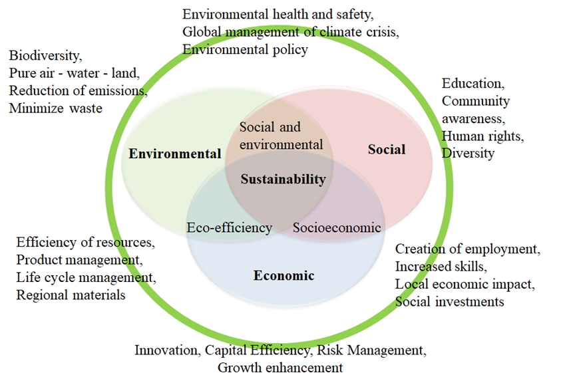
Figure 1 - Triple Bottom Line Source: Adapted from Elkington (2001).
The graphical representation of Figure 1 summarizes the three dimensions of sustainability, as well as their overlaps, creating subdimensions that are characterized by their proposition of performance. The economic dimension has innovation, capital efficiency, risk management and growth enhancement. The social dimension addresses issues such as education, community awareness, human rights, and diversity; while addressing the principles of biodiversity, clean air - water - land, reducing emissions and minimizing waste, express the aspects addressed by the environmental dimension (ELKINGTON, 2001).
The ongoing research on the subject made with that theoretical conceptions would become comprehensive and what new dimensions came up in the composition of the analytical mosaic of relations that involve the expression sustainability and its meanings. Sachs (1993) indicates an unfolding of the TBL with eight dimensions for sustainability. The number of dimensions varies significantly, consequently increasing by the complexity of the theme, as mentioned previously in the ideas of Van Bellen (2004) and Seghezzo (2009).
The development of the concept of sustainability, in its complexity, is currently much better represented by the SDG´s. Figure 2, taken from the United Nations website, indicates sustainability objectives.
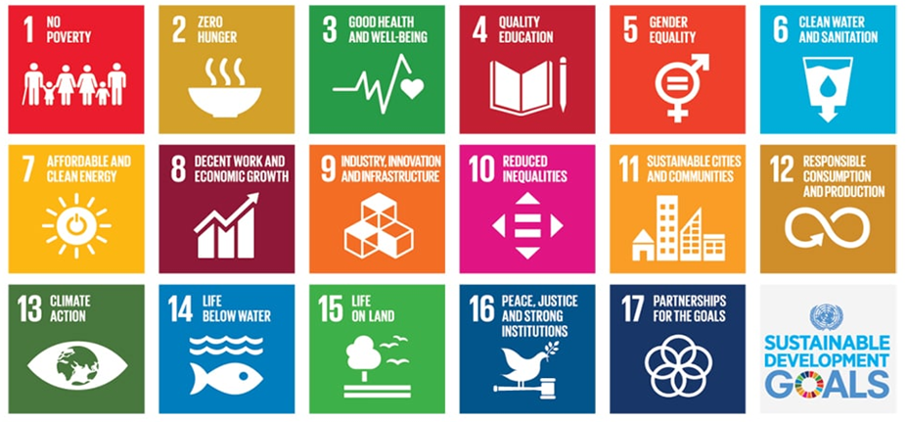
Figure 2: SDG´s - Source: SDGs, (2015)
Thus, organizational actions that act within the scope of SDGs will be directly engaged with Sustainability. And for Klewitz and Hansen (2013), an increasingly important way for companies to achieve sustainable performance lies in the enhancement of their dynamic capacities, represented by their capacity for innovation, but mainly by Absorptive Capacity.

2.2 Absorptive capacity
The first authors to consistently address the concept of absorptive capacity were Cohen and Levinthal (1990). According to them, the absorptive capacity is defined as the ability of the organization to assess the value of new external knowledge, assimilate it, and apply it for commercial purposes. In the model developed by the authors, three dimensions are presented: recognition of information value, assimilation of knowledge by the company and the application of knowledge to generate innovation.
Cohen and Levinthal (1990) argue that the ability to absorb new information will depend on the level of prior knowledge in the organization, which is related to learning skills and experiences, and to the recognition of the value of new information. The authors also discuss the importance of internal Research and Development (R&D) activities as generators of information for the organization and suggest that, in addition to this generation of new knowledge, they enhance the firm's ability to assimilate and deploy existing information. This ability causes the company to accumulate, over time, a relevant knowledge base (COHEN & LEVINTHAL, 1990).
In this same perspective, Lane and Lubatkin (1998) brought the view of absorptive capacity at the interorganizational level, establishing that absorption capacity refers to an organization's ability to learn from another organization, being determined by the relative characteristics of the two organizations. The following year, Van Den Bosch; Volberda; De Boer, (1999) argued about the dependence of the absorptive capacity of the environment in which the organization is inserted, defending the idea that organizations respond to environmental situations. Thus, the ability to absorb is the skill that involves the evaluation, acquisition, integration, and commercial use of new external knowledge.
Other researchers have devoted themselves to expanding the concepts of Absorptive capacity as Zahra and George (2002, p. 186) which conceptualize absorptive capacity as "a group of routines and organizational processes by which firms acquire, assimilate, transform and exploit knowledge to produce a dynamic organizational capacity." Lane, Koka, and Pathak (2006), which define the absorptive capacity through three processes: identifying and understanding new potentially valuable external knowledge through investigative learning; assimilate this new knowledge through transformative learning; and finally, to use this assimilated knowledge to create knowledge and commercial results (LANE, KOKA and PATHAK, 2006). The model proposed by Lane et al. (2006) includes factors that influence the results of the absorptive capacity. The authors disagree with the division proposed by Zahra and George (2002) of potential absorptive capacity (PACAP) and realized absorptive capacity (RACAP). Thus, they take up the initial view of Cohen and Levinthal (1990) with the three dimensions.
Another perspective of ACAP is presented by Todorova and Durisin (2007). The authors return to the model presented by Cohen and Levinthal (1990) with the understanding that without previous knowledge, organizations will not be ready to acquire new information and thus could not absorb it. Todorova and Durisin (2007) returns to the recognition of value as the first step of the absorptive capacity. The model proposed includes the regime of appropriability as a moderator between prior knowledge and absorptive capacity. However, the model maintained the relationship in the same way that Zahra and George (2002) propose, between absorptive capacity and competitive advantage. Another similarity observed between the models Todorova and Durisin (2007) and the model proposed by Zahra and George (2002) are the activation triggers or activation triggers that moderate the relation between prior knowledge and the absorptive capacity. However, in the model of Todorova and Durisin (2007), the authors include the relations of power also in this moderation (between prior knowledge and the absorptive capacity).
But the main point of disagreement between the model Todorova and Durisin (2007) and the model of Zahra and George (2002) is given by the fact that the model of Zahra and George (2002) presents the Acquisition as the first dimension of absorptive capacity. While Todorova and Durisin (2007) defend the initial view of Cohen and Levinthal (1990) when proposing the Recognizing of value as the first component of the absorption capacity. They argue that without prior knowledge organizations are not able to evaluate new information and thus fail to absorb them. Without a knowledge base, organizations will not be able to identify new knowledge, so that new external knowledge can be absorbed if it is necessary for the company to be able to value this new knowledge (Todorova & Durisin, 2007).
In this sense, to acquire and value knowledge and technology that the absorptive capacity can contribute to the enhancement of sustainable performance. Delmas, Hoffmann, and Kuss (2011) suggest that absorptive capacity can drive change in organizational behavior to sustainability.

2.3 Absorptive capacity and Sustainability
In perspective, sustainability and knowledge are exceptional concepts for companies to gain competitive advantage. Companies that can integrate social and environmental issues into business strategy will expand opportunities for innovation by increasing their opportunities for rapid learning (KLEWITZ; HANSEN, 2013). Thus, the view of dynamic disposition of absorptive capacity explains the success or failure of a company, the creation of wealth and / or competitive advantage over time.
Another point to emphasize is the indication that social performance is based on organizational initiatives stemming from environmental, normative, coercive, and mimetic pressures (trigger). Such pressures eventually force the development of processes of accumulation of knowledge and experience, which allows to strategically manipulate this knowledge and experience, improving the effectiveness of engagement in corporate social responsibility (TANG; HULL; ROTHENBERG, 2012).
It is necessary to comment that the question of knowledge management, more specifically in the form of acquisition to CSR, in the work of Klewitz and Hansen (2014), indicates that engagement with external actors may prove significant to affect change, not only at the organizational level, but also in industry. The authors affirm that the deep relationship with the external environment to the organizations is a priority for the acquisition of knowledge and innovative development. Thus, the development of the absorptive capacity positively influences the sustainable performance of organizations (GALBREATH; CHARLES; OCZKOWSKI, 2014; MURRAY et al., 2011).

3 METHOD: ANALYSIS OF CONTENT
This study is methodologically classified as qualitative research having as strategy the content analysis. Content analysis is defined by Krippendorff (2004) as a research technique that creates valid inferences of texts for their contexts of use. For the content analysis method, the notion of inference is especially important because the researcher uses analytical constructs, or inference rules, to answer the research questions (WHITE; MARSH, 2006).
In similarity in most steps between quantitative and qualitative research such as: selecting material that is relevant; unify the content by distinguishing words or propositions and using quotations or examples; contextualize what is in the light of the theory about the circumstances surrounding the text; and have the specific research questions in mind (Krippendorff, 2004). The result of the qualitative analysis is a composite picture of the phenomenon that can incorporate the context, population, situation, and the theoretical construct. The objective is to describe the "general picture" of a given subject, exhibiting the conceptual depth through a weighted arrangement and richness of detailed observations (White & Marsh, 2006).
Thus, the first methodological step of this study was to determine the sample. The main publishers of scientific journals worldwide were selected as the basis for the selection of texts: Scopus and Web of Science. They were selected because they contain an expressive number of high impact journals. The terms used for the searches were "Absorptive Capacity" and "Sustainability". These terms were applied to the bases generally, that is, that they were present in any part of the publication, including titles, abstracts, keywords, and texts. In the second phase of this selection was the application of a filter related to the type of document, in which selected only articles, since only they undergo peer review processes in their full version.
Following the filtering process, the period from up to 2016 was defined as the analysis period. The fourth stage of the selection was the reading and analysis of abstracts, this step was intended to select articles that have strict alignment to the subject matter of the article. The search was focused on the relation of the absorptive capacity and sustainability, and mainly by works of empirical nature, thus excluding bibliographic revisions and theoretical discussions. The proposed analyses for the content were done through the software Atlas Ti, where the software permits the search for the related terms to the research topic allowing the grouping of sentences and ideas permitting to categorize and to correlate the concepts and results of each article. This procedure consents, as previously mentioned, the construction of a conceptual framework that covers the proposed thematic space.

4 RESULTADOS
4.1 Activation triggers
Initially, it is necessary to describe what the activation triggers are and how they are treated in the classic ACAP concepts. As already mentioned in the referential, activation triggers are the causes that, in firms, cause the search for external knowledge. These causes may be internal or external to the organization and in the four revised models can be identified as follows: Activation Triggers for Todorova and Durisin (2007) and Zahra and George (2002), Recognition of Value for Cohen and Levinthal (1990) and Environmental Conditions for Lane et al. (2006). In the context of this study, Activation Triggers play a primordial role in starting the activities of knowledge absorption in organizations. So important is this assertion that the work of Shubham, Charan, and Murty (2018) is devoted exclusively to analyzing the mediation of institutional pressures, as triggers of activation, in the implementation of environmental practices. The results of the study indicate that the institutional pressure to implement corporate environmental practices is mediated by the development of organizations' ability to absorb environmental knowledge. That is, external pressure for sustainable performance drives the development of ACAP in organizations to achieve better sustainable performance.
This institutional pressure is explained by Galbreath (2017) and Segarra-Oña, Peiró-Signes, and Mondéjar-Jiménez (2016), who indicate that improving competitiveness of environmental issues (market), pressure from stakeholders (partners, suppliers), and the growing interest in green innovations pressure firms to engage in sustainability. It can be emphasized that sustainable performance is based on organizational initiatives due to environmental, normative, coercive, and mimetic pressures. These pressures end up forcing the development of processes of accumulation of knowledge and experience, which allows to strategically manipulate this knowledge and experience, improving the effectiveness in the engagement to the sustainability (Galbreath, 2017; Cooper & Molla, 2016). And almost as a sentence Hellsmark, Mossberg, Söderholm, and Frishammar (2016) state that policy initiatives aimed at strengthening absorption capacity and participation in R & D projects are key to sustainable performance.
On the other hand, Pacheco et al. (2018) indicates that possible triggers may exist based on internal routines, such as conducting initial environmental reviews, part of the routine of environmental management system standards, and adopting routines to meet environmental demands and legislations. The assimilation routines are represented by the presence of environmental training programs, clear definition of environmental goals and development of plans to achieve them, as well as the adoption of analytical tools such as life cycle analysis (LCA) to assess their impact environmental.
Complementarily Cooper and Molla (2016) explain that the extent to which triggers contribute to the development of absorptive capacity, it is also moderated by the context of organizational sustainability and, specifically, by organizational commitment, by sustainability performance indicator’s organizational structure. Dubey et al. (2017) corroborates the idea that in the internal context, compliance offers the ability to integrate, construct and reconfigure knowledge assets to drive sustainable competitive advantage. These assertions corroborate the Lane et al. (2006) model, where the authors bring the mental models of the members of the company as well as structure and processes as ACAP mediators. In this case, ACAP for sustainable performance. As shown, activation triggers have a significant importance in the process that starts the search for external green knowledge (Sustainable ACAP) in organizations, and these triggers appear internally in organizations, as externally (Shubham et al., 2018). Theoretically, could be graphically represent an ACAP model for sustainability as in Figure 4 below.

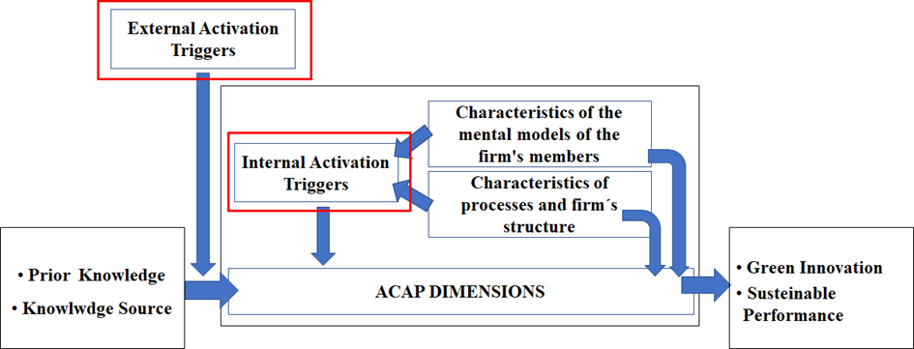
Figure 4: Internal and External Activation Triggers - Source: Authors

The external triggers can be summarized as the pressures exerted by the environment where the company is inserted, and that occur by the market, as consumers, customers, commercial partners, and competitors; or by institutional, as legal and political pressures. Internal triggers can be listed as processes and internal structures such as: compliance, performance indicators, research and development, corporate strategy, training, and employees' mindset. One observation should be made, which refers to the next item, mechanisms of social integration, as well as triggers, are extremely important for the implementation of sustainable ACAP. The assertion by Jakobsen, Lauvås, and Steinmo (2019) explains that collaborative relationships demonstrate that partners with high absorptive capacity respond consistently to environmental policy objectives, leverage existing knowledge, and improve processes. Therefore, collaboration, as well as partnerships, join ventures and other types of social relations mechanisms are also important in ACAP for sustainability, as we will see below.

4.1.2 Social integration mechanisms
As already pointed out in the theoretical framework, the mechanisms of social integration are social structures (set of people), in the form of networks, that influence the form and result in the search for knowledge in the external environment of the company. Ghassim and Foss (2018) corroborate that the market knowledge accumulated by the company acts as a facilitator for the acquisition of future knowledge through the existing network. But these networks come in many forms. Like the triggers, the mechanisms of social integration are manifested internally and externally as referenced in the reasoning by Tempelaar et al. (2008).
As for external mechanisms Garay, Font, and Pereira-Moliner (2017) e Jiang, Chun, and Yang (2018) indicate that engagement with external actors may prove significant to affect change, not only at the organizational level, but also in industry. The authors converge in their opinions in the sense that the deep relationship with the external environment to the organizations is a priority for the acquisition of knowledge and innovative development. Galbreath (2017) emphasizes the importance of harnessing new knowledge acquired through interaction with markets, reinforced by Garay, Font, and Pereira-Moliner (2017), which point out the forms of relationship: communication with non-industrial organizations, use of collective and formal information and communication within the sector's sources.
Communication within industry sources has been studied by Pace (2016) which describes that through interaction with business partners, companies become aware of innovation opportunities and develop knowledge about how to exploit them in company; in other words, companies develop an increased potential absorption capacity. The same is described by Jakobsen, Lauvås, and Steinmo (2019), where R & D partners with greater relative absorptive capacity are more likely to respond coherently to sustainable policy objectives because of their relative similarities in organizational structures, bases of dominant knowledge and logic.
The relationship with non-industrial organizations is also cited as an important means of capturing knowledge. In the paper by Ghassim and Foss (2018), the authors bring a passage from one of the interviews with a company where the interviewee states that cooperation with the technical faculties to train employees helps to guarantee the need for competence and knowledge. The authors also relate clusters as social mechanisms, where people from research organizations share their knowledge about specific issues of interest to the industry.
Internal mechanisms are described by Ghassim and Foss (2018) as the dissemination of internal knowledge by sharing experiences among colleagues in a specific unit/function; and intra-company communication channels based on technical, market and social knowledge. In support of this assertion, for Cooper and Molla (2016) contextual factors at organizational and departmental level are needed to consolidate the capacity for environmental absorption. At the organizational level, the commitment to sustainability (mental model), performance indicators and processes that link environmental sustainability to economic outcomes through accountability are important. In addition, about green knowledge exposure, the exploitation of sustainable knowledge demands connectivity with other departments oriented towards sustainability in the organization. Therefore, what is perceived is that the network composition described by Tempelaar et al. (2008) presents itself as a structure that, despite having its origin within the firm, perspires its borders to connect external sources of knowledge. But it also has a strong link to the organization's processes and routines, as well as the characteristics of collaborators' mental models. Figure 5 shows the arrangement of the mechanisms acting on the ACAP and in the relations with the sources of knowledge under the influence of the processes, routines, and mental models.

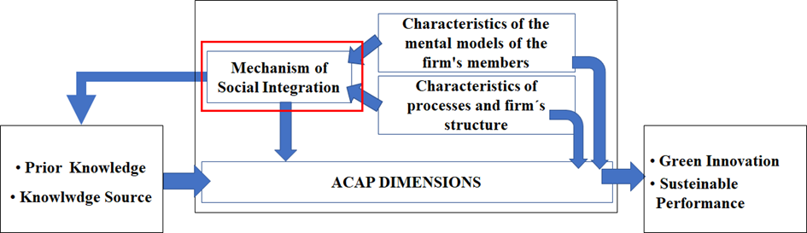
Figure 5 - Mechanism of Social Integration - Source: Authors

This model Explains better the relations proposed by the Cohen and Levinthal (1990); Zahra and George (2002); Lane et al. (2006); Todorova and Durisin (2007). In the figure it is noted that the arrow linking the mechanisms of social integration with the sources of external knowledge represent what Cohen and Levinthal (1990) called the appropriability regime and what Lane et al. (2006) called the characteristics of the learning relationship. That is, external social relations the firm that regulate the acquisition of knowledge. On the other hand, the link between the mechanisms of social integration and the dimensions of ACAP within the firm characterize exactly what Zahra and George (2002) and Todorova and Durisin (2007) also call mechanisms of social integration. They act internally in the firm in the diffusion of the new knowledge by the organizational structures. Obviously, the authors also related these mechanisms to the connection with the external sources of knowledge, but always consider them as an internal structure to the firm, disregarding that the networks extrapolate the organizational boundaries.
It is important to emphasize that both activation triggers and mechanisms of social integration influence the firm's routines and processes, as well as the mental models of its collaborators. This relationship is discussed below.

4.1.3 Activation triggers and social integration mechanisms in organizations
Throughout the topics 4.1.1 and 4.1.2, the activation triggers and the mechanisms of social integration were independently analyzed. In this topic we will discuss how the composition of these structures are related in the ACAP process to acquire green knowledge. To begin the analysis, the model shown in figure 6, which aggregates the previous two models of topics 4.1.1 and 4.1.2, containing the external and internal activation triggers, was designed; and mechanisms of social integration.

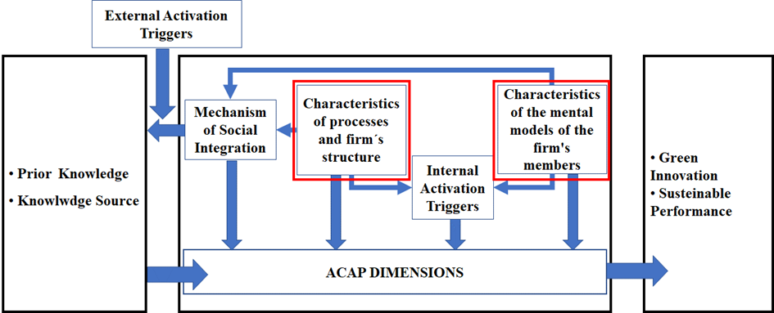
Figure 6: Activation Triggers and Social Integration Mechanisms in Organizations - Source: Authors

The first analysis is done for external triggers. As already mentioned, these triggers are represented by pressures made by the firm's environment, more specifically market competitiveness, pressure from stakeholders (partners, suppliers, customers, and competitors), policy and legislation that can translate into environmental pressures, normative, coercive, and mimetic. But such pressures can only be detected by social networks. They make it possible to detect these pressures on the firm. Therefore, it can be indicated as in the model that external triggers are directly linked to the firm's social integration mechanisms. Jakobsen, Lauvås, & Steinmo (2019) indicate that cooperative relationships (social integration mechanisms) demonstrate that partners consistently respond to environmental policy objectives (activation triggers), leveraging existing knowledge and improving processes. This dependence on integration mechanisms is so important that Hellsmark, Mossberg, Söderholm, and Frishammar (2016) indicate that external activation triggers that strengthen these networks are created in the sense of forcing the creation of networks of an industry and its participation in R & D projects.
Something very similar occurs with the internal triggers of activation. They are managed from the internal social integration networks of the firms involved in the ACAP process. As already mentioned in item 4.1.1, the triggers of internal activation are caused by the presence of training programs, development of plans, organizational context, and organizational commitment (COOPER & MOLLA, 2016; DUBEY ET AL., 2017). Liu, Zhang, & Ye (2019) believe that powerful teams can use vendors to discover knowledge of ideas, plans and projects on a sustainable basis, are the team (internal integration mechanism) has as triggers of activation the innovation discovery of a supplier (source of external knowledge). But the most significant finding is clearly the influence of the firm's structures, routines, processes and mental models on activation triggers and social integration mechanisms, which are highlighted in Figure 6. This influence is reported by Tanner, McIntosh, Widdowson, and Tillotson (2018) who emphasize that the incorporation of knowledge depends on the extent to which the organizational processes and the cultures that act to increase the absorptive capacity for the proposed innovation are already working. In the work of Gangi, Mustilli, & Varrone (2018) it is reported that the incorporation of the principles of Internal Corporate Social Responsibility in the team, processes and strategy is the starting point for the effectiveness of the external strategy of Corporate Social Responsibility.
Galbreath (2017) emphasizes that as firms increase certain types of human capital resources the implementation of green innovations is strengthened. That is, mental models that demonstrate greater sensitivity to the natural environment, and higher moral and ethical standards tend to be more amenable to implementations of green innovations. It is plausible to deduce that from appropriate mental models’ processes, routines, and structures should align with this mental model and that the ACAP process be conducted actively for green knowledge. This will probably have characteristics described previously, in items 4.1.1 and 4.1.2.

5 Conclusion
This article aimed to discuss and describe how the mechanisms of social integration and the triggers of absorptive capacity work for the sustainable performance of organizations. Successfully, in addition to discussing and describing the mechanisms of social integration and the triggers of absorption capacity, it was identified that the mental models, processes, and routines of employees directly influence issues such as activation triggers and social integration. And consequently, the result of ACAP.
In this sense, the work has its limitations, because any statement about the characteristics and profiles of the processes, routines, structures, and mental models necessary for the best performance of sustainable ACAP is weak. Thus, they remain as suggestions for new research, works that can study in detail and in depth what types of structures, processes, routine, and mental models that provide a superior performance of sustainable ACAP.

References
AL-ABRROW, H.; ALI, J.; ALNOOR, A. Multilevel Influence of Routine Redesigning, Legitimacy and Functional Affordance on Sustainability Accounting: Mediating Role of Organizational Sense-making. Global Business Review, v. 23, n. 2, p. 287–312, 1 abr. 2022.
BOWLER, K.; CASTKA, P.; BALZAROVA, M. Understanding Firms’ Approaches to Voluntary Certification: Evidence from Multiple Case Studies in FSC Certification. Journal of Business Ethics, v. 145, n. 2, p. 441–456, 2015.
COHEN, W. M.; LEVINTHAL, D. A. Absorptive Capacity: A New Perspective on and Innovation Learning. Administrative Science Quarterley, v. 35, n. 1, p. 128–152, 1990.
DELMAS, M.; HOFFMANN, V. H.; KUSS, M. Under the tip of the iceberg: Absorptive capacity, environmental strategy, and competitive advantage. Business and Society, v. 50, n. 1, p. 116–154, 2011.
GALBREATH, J.; CHARLES, D.; OCZKOWSKI, E. The Drivers of Climate Change Innovations: Evidence from the Australian Wine Industry. Journal of Business Ethics, v. 135, n. 2, p. 217–231, 2014.
KLEWITZ, J.; HANSEN, E. G. Sustainability-oriented innovation of SMEs: A systematic review. Journal of Cleaner Production, v. 65, p. 57–75, 2013.
KRIPPENDORFF, K. Reliability in content analysis: Some common misconceptions and recommendations. [s.l.] Wiley Online Library, 2004. v. 30
LANE, P. J.; LUBATKIN, M. RELATIVE AND CAPACITY LEARNING interorganizational learning. Strategic Management Journal, v. 19, n. 5, p. 461–477, 1998.
MOUSAVI, S.; BOSSINK, B.; VAN VLIET, M. Dynamic capabilities and organizational routines for managing innovation towards sustainability. Journal of Cleaner Production, v. 203, p. 224–239, 1 dez. 2018.
MURRAY, K. et al. Absorptive capacity as a guiding concept for effective public sector management and conservation of freshwater ecosystems. Environmental Management, v. 47, n. 5, p. 917–925, 2011.
SEGHEZZO, L. The five dimensions of sustainability. Environmental Politics, v. 18, n. 4, p. 539–556, 2009.
TANG, Z.; HULL, C. E.; ROTHENBERG, S. How Corporate Social Responsibility Engagement Strategy Moderates the CSR-Financial Performance Relationship. Journal of Management Studies, v. 49, n. 7, p. 1274–1303, 2012.
VAN BELLEN, H. M. Desenvolvimento sustentável: uma descrição das principais ferramentas de avaliação. Ambiente & Sociedade, v. 7, n. 1, p. 67–87, 2004.
VAN DEN BOSCH, F. A. J.; VOLBERDA, H. W.; DE BOER, M. Coevolution of Firm Absorptive Capacity and Knowledge Environment: Organizational Forms and Combinative Capabilities. Organization Science, v. 10, n. 5, p. 551–568, 1999.
WHITE, M. D.; MARSH, E. E. Content Analysis: A Flexible Methodology. Library Trends, v. 55, n. 1, p. 22–45, 2006.
ZAHRA, S. A.; GEORGE, G. Absorptive Capacity: a Review, Reconceptualization, and Extension. Academy of Management Review, v. 17, n. 2, p. 185–203, 2002.

